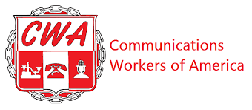

BARGAINING REPORT #24
CWA/CLIMATE REALITY BARGAINING
APRIL 20TH, 2026

Fellow CWA Members

The Union and Climate Reality have met a few times over the last 2 months. These sessions continue to move us closer to reaching an overall tentative agreement.

The last few proposals exchanged between the parties, the Union continues to craft language that will benefit the members whether it’s regarding benefits or working conditions.

We had 2 bargaining sessions in March where we exchanged counters on Discipline; Hours of Work; Performance Improvement Plan; Performance Reviews; Added Work-Work Out of Title and Duration. In our April 16th session, we were able to reach tentative agreements on those proposals. We currently remain apart on proposals concerning Benefits; Introductory Period and 401(k).

The proposal on Healthcare benefits is being critically considered against the rising cost of healthcare; quality of coverage and what Climate Reality indicates they are willing to pay. We have requested additional information to be able to propose something that will keep costs and quality of coverage as something that will remain affordable and provide a level of coverage that is adequate.

We are very close to finishing negotiations. These remaining 3-4 proposals should be worked through in the next 1-2 months with an estimated conclusion reached sometime in June. Once an overall agreement is reached, all members will be able to review all the tentative agreements. Members then cast a vote to decide whether to accept the proposed contract. If your home address has changed in the last 2-3 months, please have it updated with Climate Reality. Ballots will be mailed out to that address on file.

We will schedule a contract explanation call to review all tentative agreements prior to voting on the contract.

Your CWA Bargaining Team,

Ella Carlson; Alejandro Sobrera Barboza; Ethan Spaner; Lisa Fazzini and Melisssa Smith-Kupihea.

