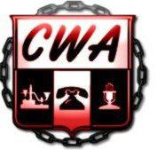
COMMUNICATIONS WORKERS OF AMERICA, AFL-CIO LOCAL 2336-DISTRICT 2-13 151 RIGGS ROAD, N.E., WASHINGTON ,D.C. 20001 OFFICE #: 202-291-1500 FAX#: 202-829-0202
WEBSITE: www.cwalocal2336.org

GRIEVANCE EXTENSION FORM

We, the undersigned, mutually agree, in accordance with the Collective Bargaining Agreement, to extend the timelimits at the ___________step until Click here to enter a date. for grievance # ______________________________ involving
_____________________________________.

Signature: _______________________________ (Company rep.)
Date: ______________________________________

Signture: ___________________________________(Union rep.)
Date: ______________________________________

