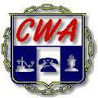

**BARGAINING REPORT**

**EVERYACTION/CWA BARGAINING**

**APRIL 5, 2022**

Fellow CWA Members,

Today the CWA Bargaining Committee met with the Company again and the Company presented their new proposed sales commission plan.

In accordance with the NLRA, the Company is obligated to bargain over any proposed changes with the Union before implementing any changes. The Bargaining Committee is reviewing this plan to make sure there are no diminishments to the compensation of our members. CWA is awaiting 2021 comparison data from the Company to ensure it’s fair and equitable for the entire membership. At first glance the new sales plan looks to be beneficial but we are waiting to analyze the requested data.

Additionally, the Bargaining Committee outright rejected the Company’s insulting counter proposal on economics from March 22nd and placed our original proposal back on the table. We look forward to reviewing the Company’s new and improved counter proposal at our next session.

**THEY MUST DO BETTER FOR THE MEMBERS!!!**

As the Company prepares their counter proposal, it is now more important than ever that every member participate in mobilizations:

* **WEAR RED EVERY THURSDAY**
* **EXPECT TO HEAR FROM A MOBILIZING COMMITTEE MEMBER SOON!**
* **CHANGE YOUR SLACK ICON TO “:cwa-strong:”**

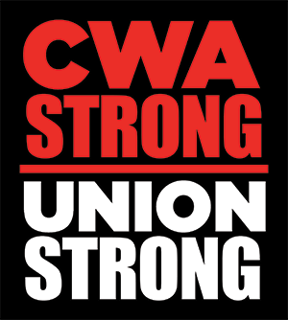

**“When We Fight, We Win!”**

In Solidarity,

Your CWA Bargaining Team:

Tonya Hodges, CWA Staff Representative

Don Trementozzi, President, CWA Local 1400

Terry Garner, President, Local 2336

Jim Gardler, President, CWA Local 13000

Keri Evinson, Executive VP, CWA Local 1400

Melissa Smith-Kupihea, Executive VP, CWA Local 2336

Jeff Reamer, Executive VP, CWA Local 13000

Karen Cusson, Recording Secretary, CWA Local 1400

Mike Murray, CWA Local 1400

Jennifer Willis, CWA Local 1400

Grace Duginski, CWA Local 2336

MJ Flott, CWA Local 13000