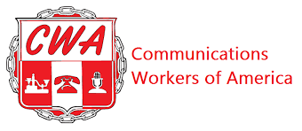

BARGAINING REPORT #2
CWA/CLIMATE REALITY BARGAINING
FEBRUARY 23, 2024

Fellow CWA Members:

The Union and the Employer met again today to continue negotiating our first contract. We also met on Wednesday, 2/21.

On Wednesday, 2/21, Climate Reality responded to CWA’s first 5 proposals with counters. Those proposals covered Recognition; Dues Deduction; Union Security; Political Action Fund and Non-Discrimination. The Employer made minor word changes and after the CWA Bargaining Committee reviewed the changes the Union moved to accept the counter proposals. These proposals became tentative agreements. This means each article was negotiated and the final pass was acceptable to both parties. Each party then signed off on each proposal.

Part of Wednesday and Friday’s negotiating sessions were spent discussing issues affecting our members. We had extensive conversation with Climate Reality surrounding exempt and non-exempt statuses. The Union questioned why some employees’ statuses were changed after hire; how notification is provided and what the job descriptions reflect. We also discussed classifications of employees- full time versus part time employees and benefits afforded each.

During Friday’s session the Union discussed the right our members should have to express opinions about current events without reprisal and asked questions about Climate Reality’s Work from Home policy as well as their Temporary and Permanent Relocation Policies.

Our next scheduled bargaining session is Friday, March 8th.

Your CWA Bargaining Team,

Ella Carlson; Sena Wazer; Vivienne Maxwell; Julia Ridgely and Lisa Fazzini

