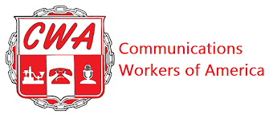
CWA/PRECISION STRATEGIES BARGAINING REPORT #1
TUESDAY, MAY 28, 2024

Dear fellow CWA members,

Your CWA bargaining committee met virtually today with Precision Strategies’ management bargaining team for our first bargaining session.

CWA kicked off the session by introducing the CWA Bargaining Committee (names listed below), and Precision Strategies also introduced their team. Teddy Goff, Thomas Reno, Stephanie Cutter, and attorney Micheal McGuire serve on management’s negotiating team.

The Union presented five proposals that focused on Recognition, Union Security, Dues Deduction, No-Strike-No-Lockout, and Non-discrimination. If necessary, Precision Strategies will review and counter in a future session.

The Union questioned Precision Strategies about their most recent change in time off. Thomas Reno clarified that it just pertained to floating holidays. The only change was setting a defined amount of advanced notice to 2 days. The Union advised that any change in working conditions, benefits, or compensation needs to be sent to the Union ahead of the bargaining unit so that we can review and determine whether to bargain over the change. We advised that we would address this issue in the bargaining process.

The session ended after the Union reviewed a request for information we submitted to get employee data, wage information, and policy and handbook information.

Our next virtual session is scheduled for Monday, June 3rd, 2024.

During the negotiation process, we must continuously demonstrate that we’re united in achieving our goal of reaching a robust and fair contract. When you are asked to participate in a mobilization activity, please join us.

Your bargaining committee,

Lisa Fazzini-CWA Staff Representative-Bargaining Chair
Omer Qureshi
Sam Tuero
Chris Koh-Local 2336 Representative
Jake Ward-Local 2336 Representative

