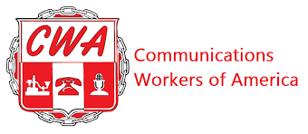

BARGAINING REPORT #21
CWA/CLIMATE REALITY BARGAINING
December 2, 2025

Fellow CWA Members:

The Union and the Employer met today. The Union presented a package of economic counters about WAGES; SALARY BANDS; COLA and REMOTE WORK. We impressed upon Climate Reality that this package contained the most important proposals to the bargaining unit. Survey results consistently ranked these as the top issues.

We are at the end of this bargaining process and need support to get language that will benefit the bargaining unit and lift your economic standing. Our next bargaining session is on 12/16/25, the day of our All-Staff Meeting. Please be visible in your support by displaying a Union background.

If you have more questions and want more details we will be hosting an All Member meeting before the winter break. Please be on the lookout for invite details for this call.

Your CWA Bargaining Team,

Ella Carlson; Alejandro Sobrera Barboza; Ethan Spaner and Lisa Fazzini

