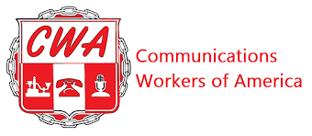

BARGAINING REPORT #22
CWA/CLIMATE REALITY BARGAINING
January 13, 2026

Fellow CWA Members:

Happy New Year to everyone. The Union and Climate Reality met today. The Union presented counters on AI and Personal Leave. We also agreed to tentatively agree to other counters presented on Immigrant Worker Protections; Safety & Health; Jury and Witness Duty and Wellness Leave.

We are about to finish the bargaining process with just 8-9 proposals remaining that need to be worked through. All members will be able to review all of the tentative agreements once an overall agreement is reached. Members then cast a vote to decide whether to accept the proposed contract.

This is a crucial time to stand together. Please continue to participate in mobilization asks. Reminders of upcoming activities will be emailed. We are hoping to have negotiations finalized by end of February and at the next All Staff meetings please use union backgrounds to help demonstrate our commitment to reaching a fair contract.

If you have more questions and want more details we will be hosting an All Member meeting on 1/20/26 at 7:30 p.m. If you did not already receive an invite with call details, please let one of the bargaining committee members know.

Your CWA Bargaining Team,

Ella Carlson; Alejandro Sobrera Barboza; Ethan Spaner and Lisa Fazzini

