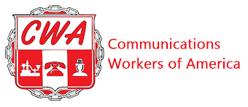
CWA/MISSIONWIRED BARGAINING REPORT #24
MONDAY, FEBRUARY 9, 2026

Hello fellow members:

Your CWA bargaining committee met with MissionWired, Monday, February 9, 2026. The Union passed 4 counters regarding WAGES; WAGE TABLES; AI and IMMIGRANT WORKER PROTECTIONS. This is the Union’s first counter on WAGES AND WAGE TABLES after reviewing MissionWired’s WAGE AND WAGE TABLE counters passed in December. We are not in alignment on the salary band minimum and maximum tables for all departments but are working toward increases for all.

Negotiations will continue until we have an agreement on all outstanding proposals but the Union has passed everything across the table that we intended to. We have a few more scheduled sessions for this month and next month to try and wrap up negotiations.

When we reach an overall tentative agreement we will hold a call with the membership to review a summary of all proposals before the bargaining unit votes on accepting the contract. Continue to show support for your bargaining committee. We want to finish as engaged as we started.

Your bargaining committee,

Lisa Fazzini-CWA Staff Representative-Bargaining Chair
Brandon Henryi-CWA Local 2336 VP Emily Profeta
Kelsey Evans
Abby Hardin

