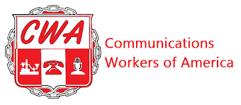
CWA/MISSIONWIRED BARGAINING REPORT #25

Hello fellow members:

Your CWA bargaining committee met with MissionWired today, March 5th. We passed the last of the counters we owed MissionWired which were Artificial Intelligence and Successorship. The Union reached a tentative agreement on proposals for WAGES AND WAGE TABLES. We were able to secure increases in every pay band and across the board raised the minimum pay band in every title that was below $60,000 to a minimum of $60,000.

MissionWired indicated they would review our counters. Once we reach tentative agreements on these remaining counters we will have achieved an overall tentative agreement. Copies of all the tentative agreements will be packaged together for review by the bargaining unit. The bargaining committee will also hold an all-member contract explanation call to provide the summary details of each proposal. Members can expect that call to take place about one week after we reach an overall tentative agreement.

Local 2336 will put together a ballot and summary that will be mailed to each member. Please make sure your home address information is updated or accurate in Rippling within the next 2 weeks. Every member will get to vote on the contract. We are so close to achieving a fair first contract. Your mobilization support along the way has helped as was the tremendous input from all the bargaining committee members.

Our next bargaining meeting with management is scheduled for Monday, March 16th.

Your bargaining committee,

Lisa Fazzini-CWA Staff Representative-Bargaining Chair
Brandon Henry-CWA Local 2336 Executive Vice-President
Kelsey Evans
Abby Hardin

